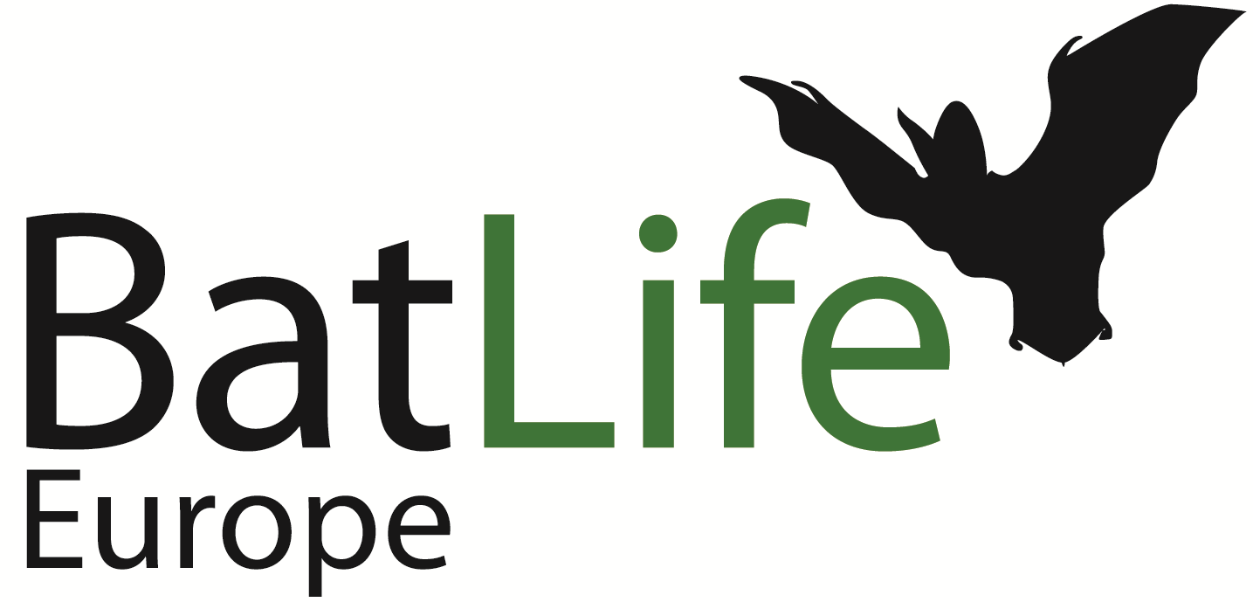

Bat Species of the Year 2024-2025
GREATER MOUSE-EARED BAT (Myotis myotis)

Online Talk

Dr Andreas Zahn has kindly offered to give a talk on the Greater Mouse-Eared Bat, on Wednesday 17th January 2024 at 8pm CET (7pm GMT).

The link and details for the Zoom session are below.

Topic: BLE Greater Mouse-Eared Bat Talk
Time: Jan 17, 2024 08:00 PM CET 07:00 PM GMT
https://us02web.zoom.us/j/89666636955?pwd=cVFNNEpNTVBzbEl4Mzg0bjVxWHUxdz09
Meeting ID: 896 6663 6955
Passcode: 833657



